COGNIZANT SUPERSET ID : 6424916

**DESIGN PATTERNS**

**Exercise 1: Implementing the Singleton Pattern.**

**Main.java:**

package Design.SingletonPattern;

public class Main {

    public static void main(String[] args) {

        Logger logger1 = Logger.getInstance();

        logger1.log("This is the first log message.");

        Logger logger2 = Logger.getInstance();

        logger2.log("This is the second log message.");

        if (logger1 == logger2) {

            System.out.println("Both logger instances are the same (singleton works).");

        } else {

            System.out.println("Logger instances are different (singleton failed).");

        }

    }

}

**Logger.java:**

package Design.SingletonPattern;

public class Logger {

    private static Logger instance;

    private Logger() {

        System.out.println("Logger initialized.");

    }

    public static Logger getInstance() {

        if (instance == null) {

            instance = new Logger(); // only initialized once

        }

        return instance;

    }

    public void log(String message) {

        System.out.println("Log: " + message);

    }

}

**OUTPUT:**

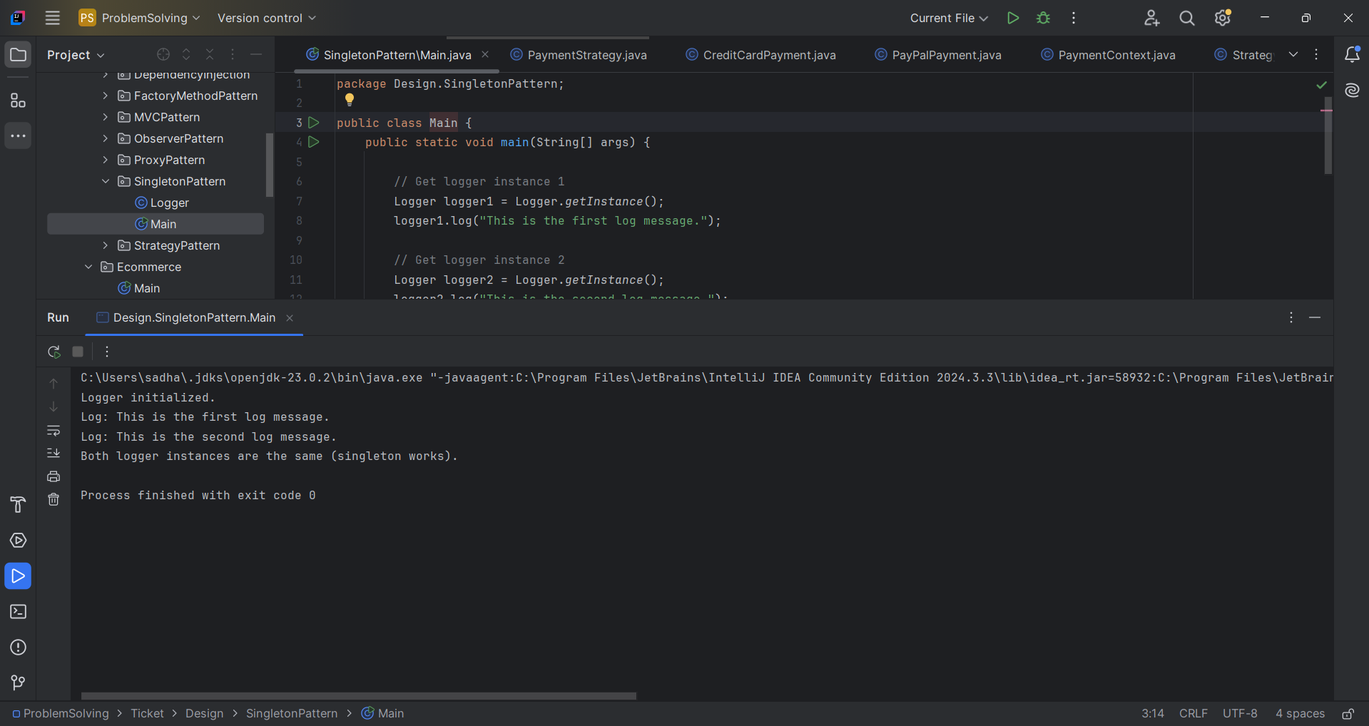

**Exercise 2: Implementing the Factory Method Pattern**

**document.java:**

package Design.FactoryMethodPattern;

public interface Document {

    void open();

}

**Documentfactory.java:**

package Design.FactoryMethodPattern;

public abstract class DocumentFactory {

public abstract Document createDocument();

}

**Exceldocument.java:**

package Design.FactoryMethodPattern;

public class ExcelDocument implements Document {

    @Override

    public void open() {

        System.out.println("Opening an Excel document.");

    }

}

**Exceldocument factory.java:**

package Design.FactoryMethodPattern;

public class ExcelDocumentFactory extends DocumentFactory {

    @Override

    public Document createDocument() {

        return new ExcelDocument();

    }

}

**Main.java:**

package Design.FactoryMethodPattern;

public class Main {

    public static void main(String[] args) {

        DocumentFactory wordFactory = new WordDocumentFactory();

        Document wordDoc = wordFactory.createDocument();

        wordDoc.open();

        DocumentFactory pdfFactory = new PdfDocumentFactory();

        Document pdfDoc = pdfFactory.createDocument();

        pdfDoc.open();

        DocumentFactory excelFactory = new ExcelDocumentFactory();

        Document excelDoc = excelFactory.createDocument();

        excelDoc.open();

    }

}

**Pdfdocument.java:**

package Design.FactoryMethodPattern;

public class PDFDocument implements Document {

    @Override

    public void open() {

        System.out.println("Opening a PDF document.");

    }

}

**Pdfdocumentfactory.java:**

package Design.FactoryMethodPattern;

public class PdfDocumentFactory extends DocumentFactory {

    @Override

    public Document createDocument() {

        return new PDFDocument();

    }

}

**Worddocument.java:**

package Design.FactoryMethodPattern;

public class WordDocument implements Document {

    @Override

    public void open() {

        System.out.println("Opening a Word document.");

    }

}

**Worddocumentfactory.java:**

package Design.FactoryMethodPattern;

public class WordDocumentFactory extends DocumentFactory {

    @Override

    public Document createDocument() {

        return new WordDocument();

    }

}

**OUTPUT:**

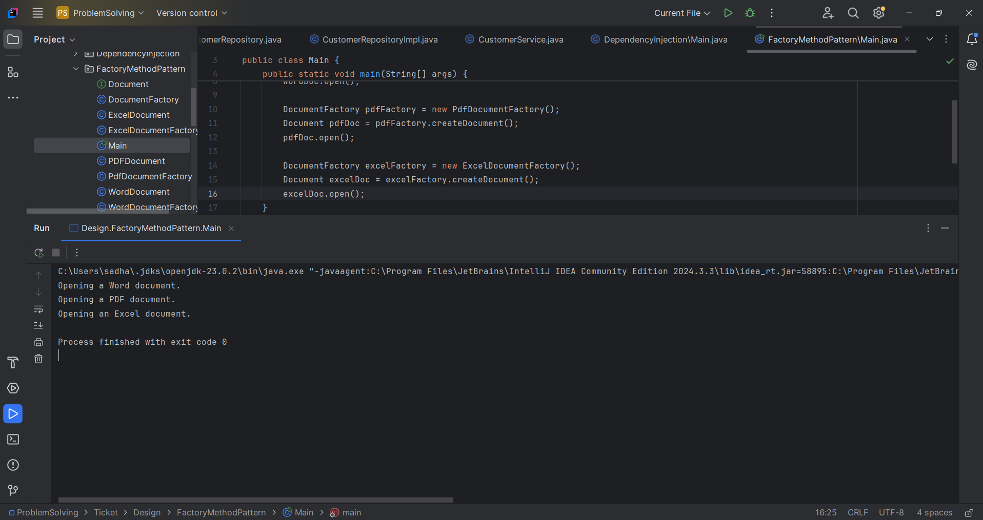

**Exercise 3: Implementing the Builder Pattern**

**Main.java:**

package Design.BuilderPattern;

public class Main {

    public static void main(String[] args) {

        Computer basicPC = new Computer.Builder()

                .setCPU("Intel i3")

                .setRAM("8GB")

                .setStorage("256GB SSD")

                .build();

        basicPC.showConfig();

        System.out.println();

        Computer gamingPC = new Computer.Builder()

                .setCPU("Intel i9")

                .setRAM("32GB")

                .setStorage("1TB SSD")

                .setGraphicsCard("NVIDIA RTX 4090")

                .build();

        gamingPC.showConfig();

    }

}

**Computer.java:**

package Design.BuilderPattern;

public class Computer {

    private final String CPU;

    private final String RAM;

    private final String storage;

    private final String graphicsCard;

    private Computer(Builder builder) {

        this.CPU = builder.CPU;

        this.RAM = builder.RAM;

        this.storage = builder.storage;

        this.graphicsCard = builder.graphicsCard;

    }

    public void showConfig() {

        System.out.println("Computer Configuration:");

        System.out.println("CPU: " + CPU);

        System.out.println("RAM: " + RAM);

        System.out.println("Storage: " + storage);

        System.out.println("Graphics Card: " + (graphicsCard != null ? graphicsCard : "None"));

    }

    public static class Builder {

        private String CPU;

        private String RAM;

        private String storage;

        private String graphicsCard;

        public Builder setCPU(String CPU) {

            this.CPU = CPU;

            return this;

        }

        public Builder setRAM(String RAM) {

            this.RAM = RAM;

            return this;

        }

        public Builder setStorage(String storage) {

            this.storage = storage;

            return this;

        }

        public Builder setGraphicsCard(String graphicsCard) {

            this.graphicsCard = graphicsCard;

            return this;

        }

        public Computer build() {

            return new Computer(this);

        }

    }

}

**Output:**

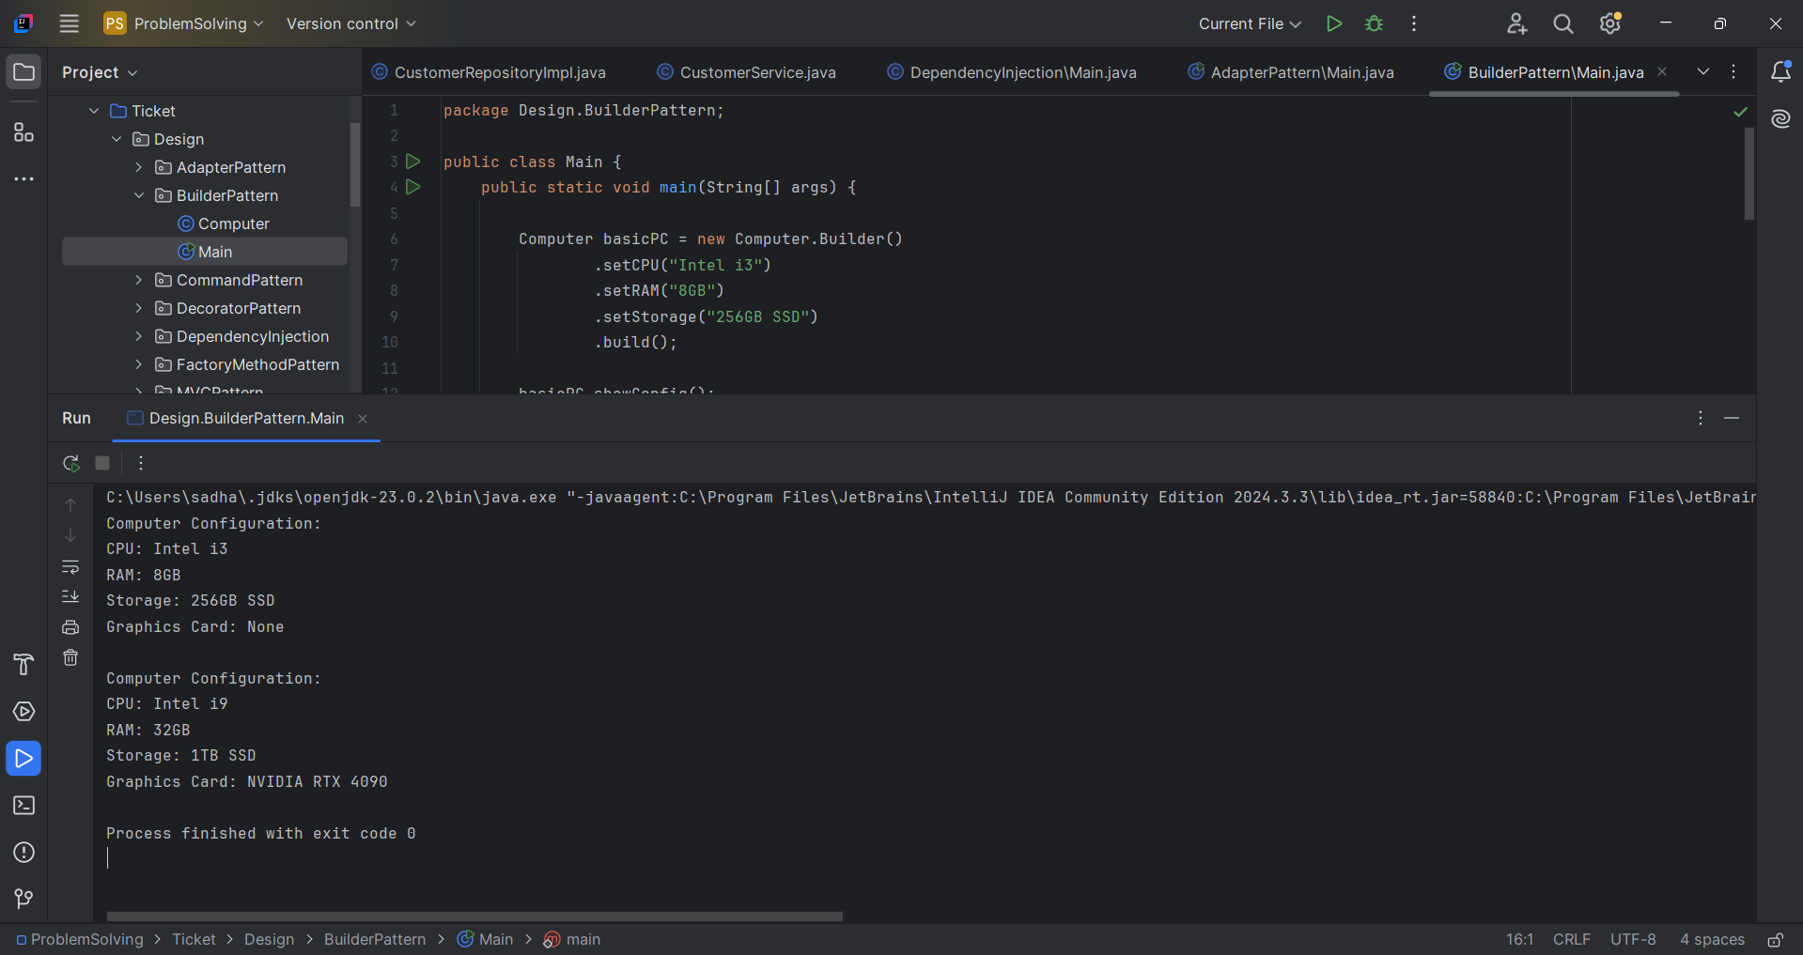

**Exercise 4: Implementing the Adapter Pattern**

**Main.java:**

package Design.AdapterPattern;

public class Main {

    public static void main(String[] args) {

        // Use PayPal through adapter

        PaymentProcessor paypalProcessor = new PayPalAdapter(new PayPalSDK());

        paypalProcessor.processPayment(150.00);

        System.out.println();

        PaymentProcessor stripeProcessor = new StripeAdapter(new StripeSDK());

        stripeProcessor.processPayment(99.99);

    }

}

**Paymentprocessor.java:**

package Design.AdapterPattern;

public interface PaymentProcessor {

    void processPayment(double amount);

}

**Paypaladapter.java:**

package Design.AdapterPattern;

public class PayPalAdapter implements PaymentProcessor {

    private PayPalSDK payPalSDK;

    public PayPalAdapter(PayPalSDK payPalSDK) {

        this.payPalSDK = payPalSDK;

    }

    @Override

    public void processPayment(double amount) {

        payPalSDK.sendPayment(amount); // adapt to PayPalSDK

    }

}

**Stripe adapter.java:**

package Design.AdapterPattern;

public class StripeAdapter implements PaymentProcessor {

    private StripeSDK stripeSDK;

    public StripeAdapter(StripeSDK stripeSDK) {

        this.stripeSDK = stripeSDK;

    }

    @Override

    public void processPayment(double amount) {

        stripeSDK.makePayment(amount * 100);

    }

}

**Stripesdk.java:**

package Design.AdapterPattern;

public class StripeSDK {

    public void makePayment(double amountInCents) {

        System.out.println("Payment of $" + (amountInCents / 100) + " processed via Stripe.");

    }

}

**OUTPUT:**

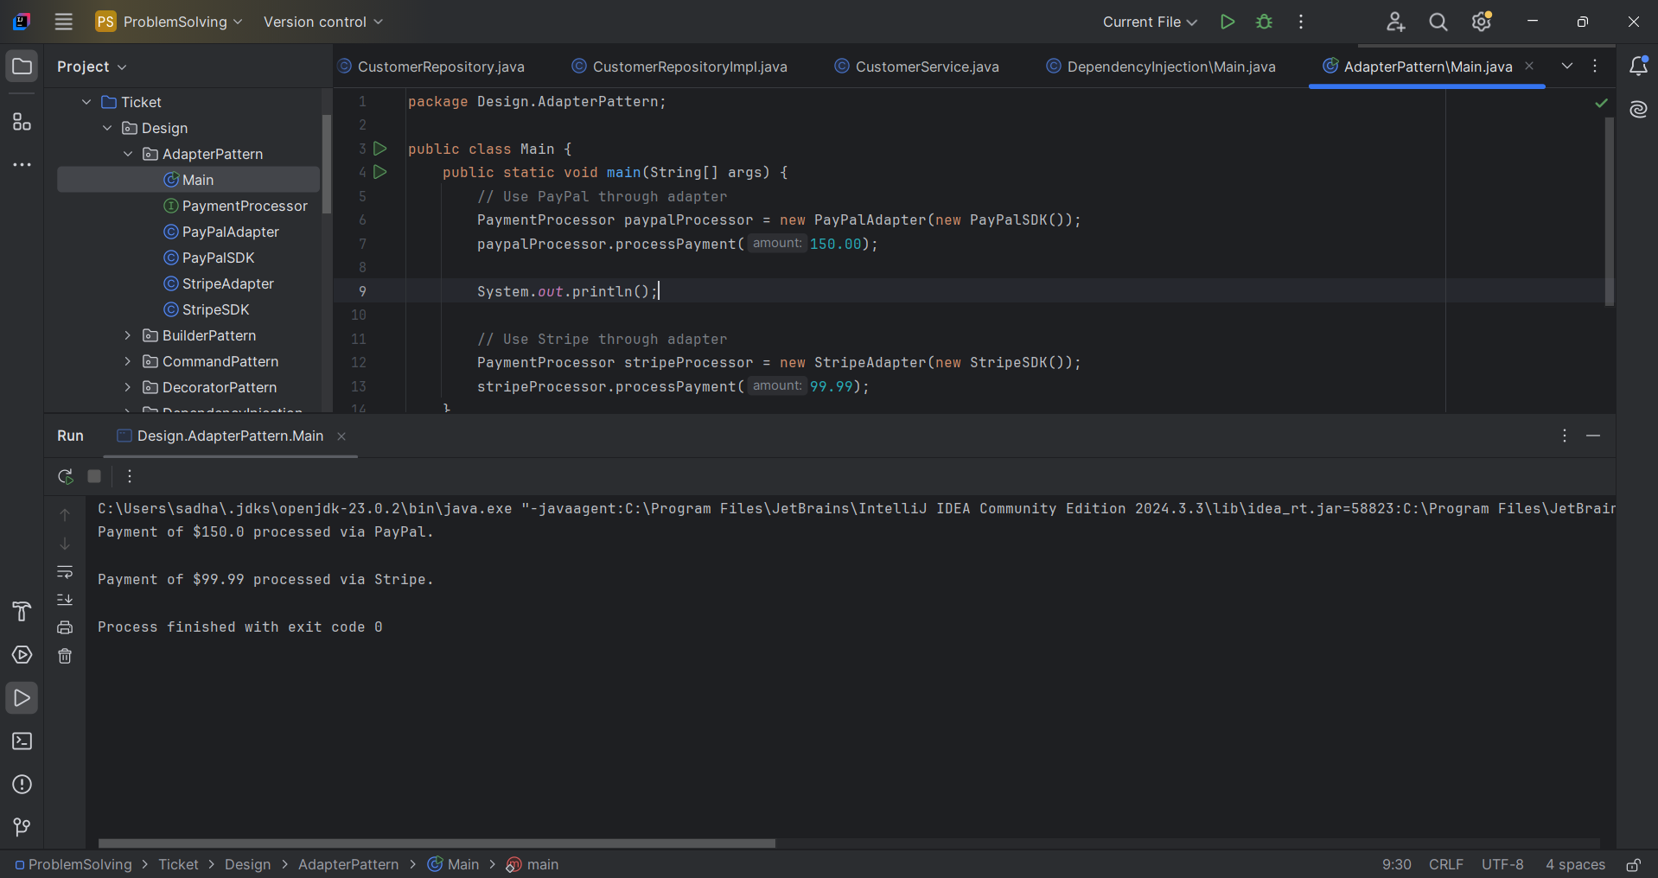

**Exercise 5: Implementing the Decorator Pattern**

**Emailnotifier.java:**

package Design.DecoratorPattern;

public class EmailNotifier implements Notifier {

    @Override

    public void send(String message) {

        System.out.println("Sending Email: " + message);

    }

}

**main.java:**

package Design.DecoratorPattern;

public class Main {

    public static void main(String[] args) {

        Notifier email = new EmailNotifier();

        Notifier emailWithSMS = new SMSNotifierDecorator(email);

        Notifier emailWithSMSAndSlack = new SlackNotifierDecorator(emailWithSMS);

        emailWithSMSAndSlack.send("Server is down!");

    }

}

**Notifier.java:**

package Design.DecoratorPattern;

public interface Notifier {

    void send(String message);

}

**Notifierdecorator.java:**

package Design.DecoratorPattern;

public abstract class NotifierDecorator implements Notifier {

    protected Notifier wrappedNotifier;

    public NotifierDecorator(Notifier notifier) {

        this.wrappedNotifier = notifier;

    }

    @Override

    public void send(String message) {

        wrappedNotifier.send(message);

    }

}

**Slacknotifier decorator.java:**

package Design.DecoratorPattern;

public class SlackNotifierDecorator extends NotifierDecorator {

    public SlackNotifierDecorator(Notifier notifier) {

        super(notifier);

    }

    @Override

    public void send(String message) {

        super.send(message);

        System.out.println("Sending Slack message: " + message);

    }

}

**Smsnotifier decorator.java:**

package Design.DecoratorPattern;

public class SMSNotifierDecorator extends NotifierDecorator {

    public SMSNotifierDecorator(Notifier notifier) {

        super(notifier);

    }

    @Override

    public void send(String message) {

        super.send(message);

        System.out.println("Sending SMS: " + message);

    }

}

**Output:**

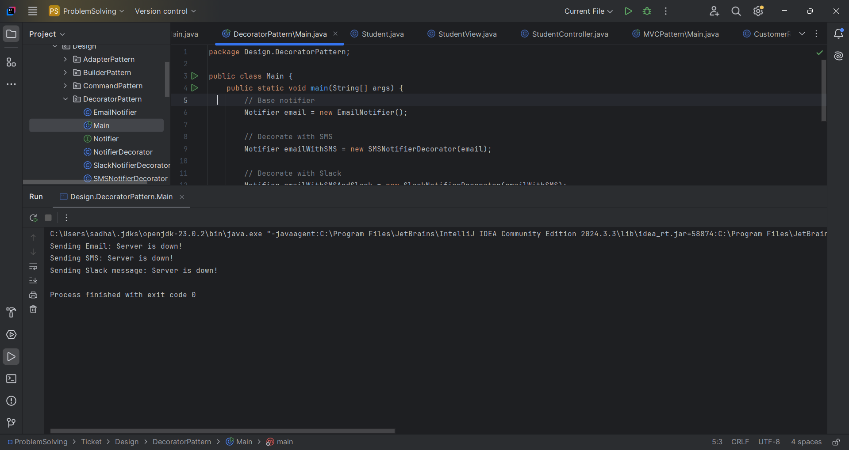

**Exercise 6: Implementing the Proxy Pattern**

**Main.java:**

package Design.ProxyPattern;

public class Main {

    public static void main(String[] args) {

        Image image1 = new ProxyImage("photo1.jpg");

        image1.display();

        System.out.println();

        image1.display();

        System.out.println();

        Image image2 = new ProxyImage("photo2.png");

        image2.display();

    }

}

**Proxyimage.java:**

package Design.ProxyPattern;

public class ProxyImage implements Image {

    private RealImage realImage;

    private String fileName;

    public ProxyImage(String fileName) {

        this.fileName = fileName;

    }

    @Override

    public void display() {

        if (realImage == null) {

            realImage = new RealImage(fileName);

        } else {

            System.out.println("Using cached image: " + fileName);

        }

        realImage.display();

    }

}

**Image.java**

package Design.ProxyPattern;

public interface Image {

    void display();

}

**Realimage.java:**

package Design.ProxyPattern;

public class RealImage implements Image {

    private String fileName;

    public RealImage(String fileName) {

        this.fileName = fileName;

        loadFromRemoteServer();

    }

    private void loadFromRemoteServer() {

        System.out.println("Loading image from remote server: " + fileName);

    }

    @Override

    public void display() {

        System.out.println("Displaying image: " + fileName);

    }

}

**OUTPUT:**

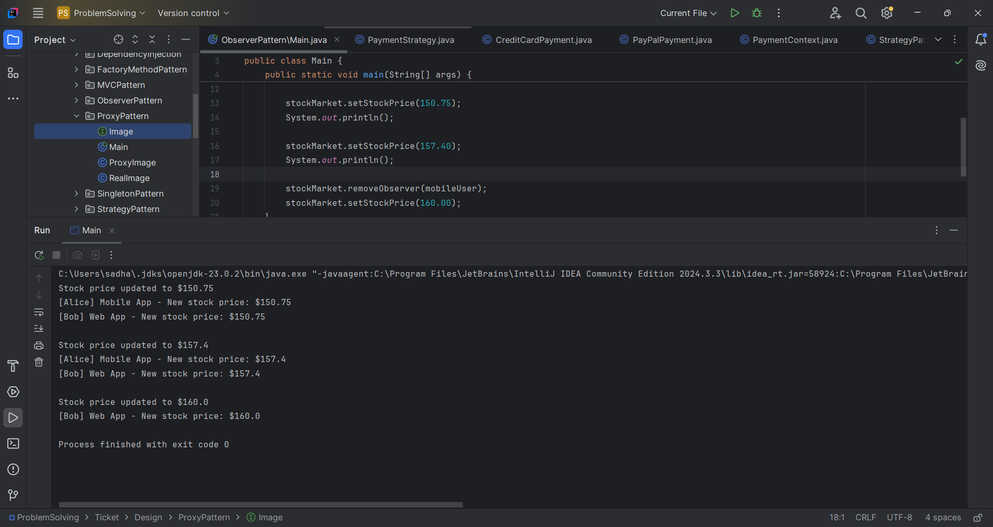

**Exercise 7: Implementing the Observer Pattern**

Main.java:

ackage Design.ObserverPattern;

public class Main {

    public static void main(String[] args) {

        StockMarket stockMarket = new StockMarket();

        Observer mobileUser = new MobileApp("Alice");

        Observer webUser = new WebApp("Bob");

        stockMarket.registerObserver(mobileUser);

        stockMarket.registerObserver(webUser);

        stockMarket.setStockPrice(150.75);

        System.out.println();

        stockMarket.setStockPrice(157.40);

        System.out.println();

        stockMarket.removeObserver(mobileUser);

        stockMarket.setStockPrice(160.00);

    }

}

Mobileapp.java:

package Design.ObserverPattern;

public class MobileApp implements Observer {

    private String name;

    public MobileApp(String name) {

        this.name = name;

    }

    @Override

    public void update(double stockPrice) {

        System.out.println("[" + name + "] Mobile App - New stock price: $" + stockPrice);

    }

}

Observer.java:

package Design.ObserverPattern;

public interface Observer {

    void update(double stockPrice);

}

Stock.java:

package Design.ObserverPattern;

public interface Stock {

    void registerObserver(Observer observer);

    void removeObserver(Observer observer);

    void notifyObservers();

}

Stockmarket.java:

package Design.ObserverPattern;

import java.util.ArrayList;

import java.util.List;

public class StockMarket implements Stock {

    private List<Observer> observers = new ArrayList<>();

    private double stockPrice;

    @Override

    public void registerObserver(Observer observer) {

        observers.add(observer);

    }

    @Override

    public void removeObserver(Observer observer) {

        observers.remove(observer);

    }

    @Override

    public void notifyObservers() {

        for (Observer observer : observers) {

            observer.update(stockPrice);

        }

    }

    public void setStockPrice(double price) {

        System.out.println("Stock price updated to $" + price);

        this.stockPrice = price;

        notifyObservers();

    }

}

Webapp.java:

package Design.ObserverPattern;

public class WebApp implements Observer {

    private String name;

    public WebApp(String name) {

        this.name = name;

    }

    @Override

    public void update(double stockPrice) {

        System.out.println("[" + name + "] Web App - New stock price: $" + stockPrice);

    }

}

Output:

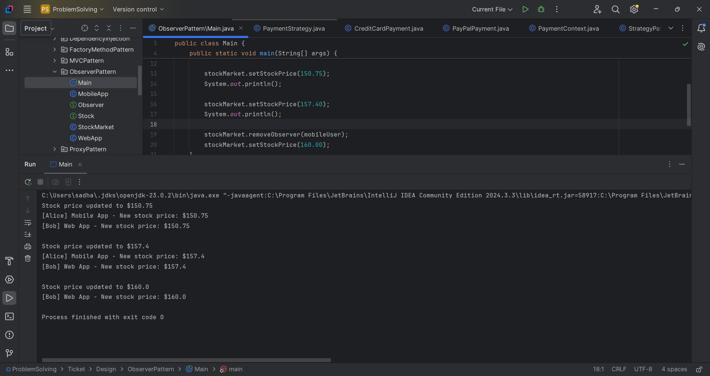

**Exercise 8: Implementing the Strategy Pattern**

**Main.java:**

package Design.StrategyPattern;

public class Main {

    public static void main(String[] args) {

        PaymentContext context = new PaymentContext();

        context.setPaymentStrategy(new CreditCardPayment("1234567812345678"));

        context.payAmount(250.75);

        System.out.println();

        context.setPaymentStrategy(new PayPalPayment("user@example.com"));

        context.payAmount(99.99);

    }

}

**Creditcardpayment.java:**

package Design.StrategyPattern;

public class CreditCardPayment implements PaymentStrategy {

    private String cardNumber;

    public CreditCardPayment(String cardNumber) {

        this.cardNumber = cardNumber;

    }

    @Override

    public void pay(double amount) {

        System.out.println("Paid $" + amount + " using Credit Card ending in " +

                cardNumber.substring(cardNumber.length() - 4));

    }

}

**Paymentcontext.java:**

package Design.StrategyPattern;

public class PaymentContext {

    private PaymentStrategy strategy;

    public void setPaymentStrategy(PaymentStrategy strategy) {

        this.strategy = strategy;

    }

    public void payAmount(double amount) {

        if (strategy == null) {

            System.out.println("No payment method selected.");

        } else {

            strategy.pay(amount);

        }

    }

}

**Paymentstrategy.java:**

package Design.StrategyPattern;

public interface PaymentStrategy {

    void pay(double amount);

}

**Paypalpayment.java:**

package Design.StrategyPattern;

public class PayPalPayment implements PaymentStrategy {

    private String email;

    public PayPalPayment(String email) {

        this.email = email;

    }

    @Override

    public void pay(double amount) {

        System.out.println("Paid $" + amount + " using PayPal account: " + email);

    }

}

**Output:**

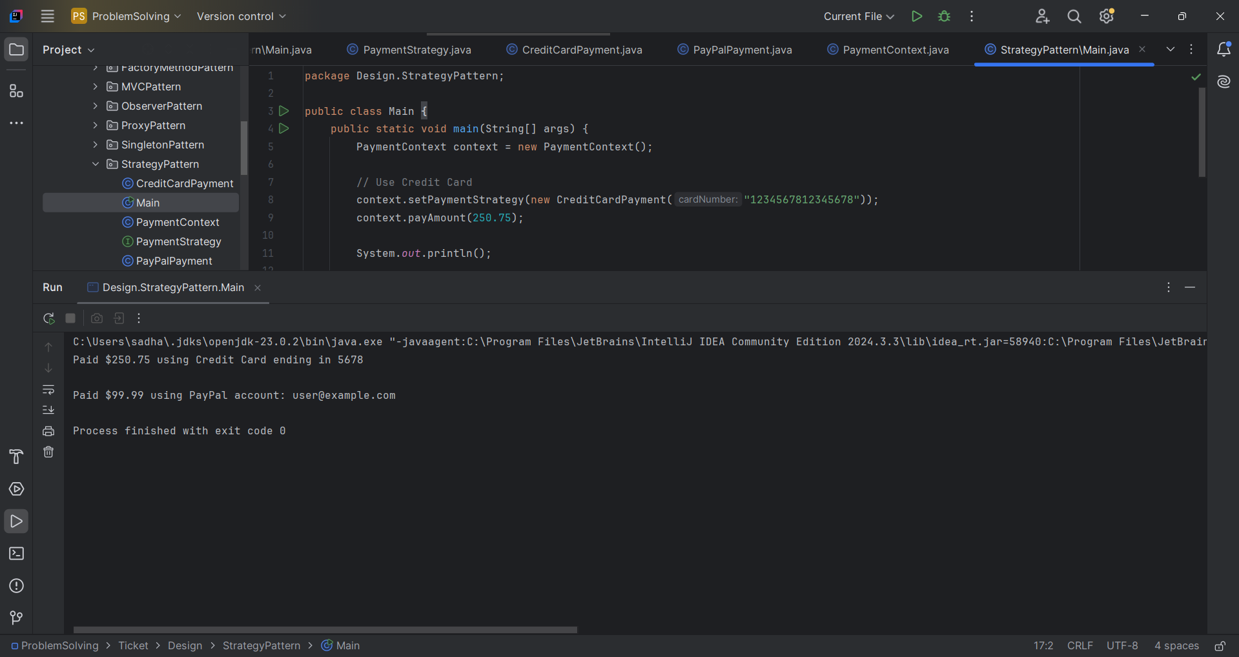

**Exercise 9: Implementing the Command Pattern**

**Main.java**

package Design.CommandPattern;

public class Main {

    public static void main(String[] args) {

        Light livingRoomLight = new Light();

        Command lightOn = new LightOnCommand(livingRoomLight);

        Command lightOff = new LightOffCommand(livingRoomLight);

        RemoteControl remote = new RemoteControl();

        // Turn ON the light

        remote.setCommand(lightOn);

        remote.pressButton();

        // Turn OFF the light

        remote.setCommand(lightOff);

        remote.pressButton();

    }

}

**Command.java:**

package Design.CommandPattern;

public interface Command {

    void execute();

}

**Light.java:**

package Design.CommandPattern;

public class Light {

    public void turnOn() {

        System.out.println("The light is ON.");

    }

    public void turnOff() {

        System.out.println("The light is OFF.");

    }

}

**LightOffCommand.java:**

package Design.CommandPattern;

public class LightOffCommand implements Command {

    private Light light;

    public LightOffCommand(Light light) {

        this.light = light;

    }

    @Override

    public void execute() {

        light.turnOff();

    }

}

**LightOnCommand.java:**

package Design.CommandPattern;

public class LightOnCommand implements Command {

    private Light light;

    public LightOnCommand(Light light) {

        this.light = light;

    }

    @Override

    public void execute() {

        light.turnOn();

    }

}

**RemoteControl.java**:

package Design.CommandPattern;

public class RemoteControl {

    private Command command;

    public void setCommand(Command command) {

        this.command = command;

    }

    public void pressButton() {

        if (command != null) {

            command.execute();

        } else {

            System.out.println("No command set.");

        }

    }

}

Output:

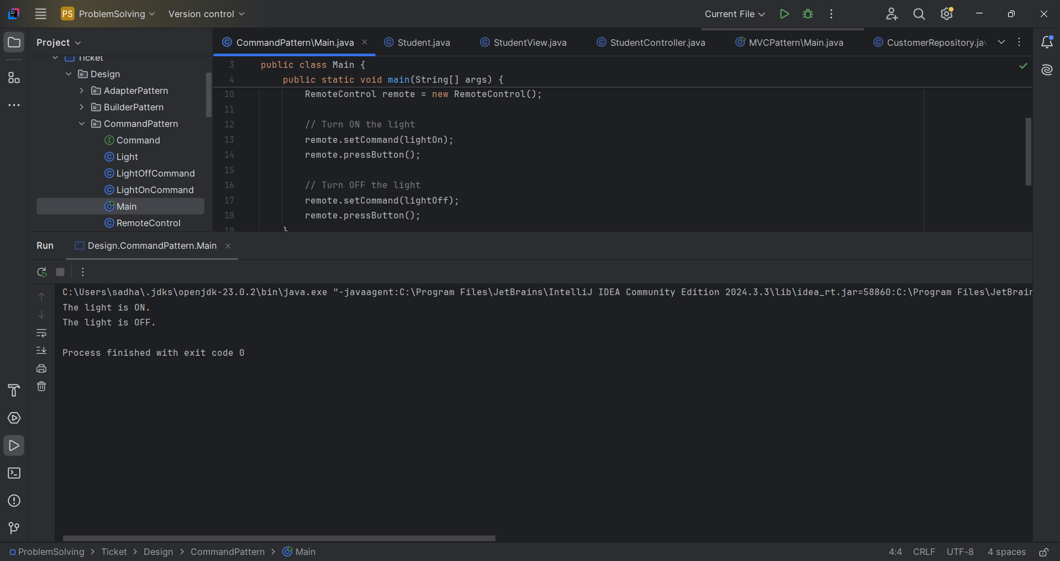

**Main.java**

package Design.MVCPattern;

public class Main {

    public static void main(String[] args) {

        Student student = new Student();

        student.setId("S001");

        student.setName("John Doe");

        student.setGrade("A");

        StudentView view = new StudentView();

        StudentController controller = new StudentController(student, view);

        controller.updateView();

        System.out.println("\nUpdating student data...\n");

        controller.setStudentName("Jane Smith");

        controller.setStudentGrade("B+");

        controller.updateView();

    }

}

**Student.java:**

package Design.MVCPattern;

public class Student {

    private String id;

    private String name;

    private String grade;

    public String getId() {

        return id;

    }

    public void setId(String id) {

        this.id = id;

    }

    public String getName() {

        return name;

    }

    public void setName(String name) {

        this.name = name;

    }

    public String getGrade() {

        return grade;

    }

    public void setGrade(String grade) {

        this.grade = grade;

    }

}

**Studentcontroller.java:**

package Design.MVCPattern;

public class StudentController {

    private Student model;

    private StudentView view;

    public StudentController(Student model, StudentView view) {

        this.model = model;

        this.view = view;

    }

    public void setStudentName(String name) {

        model.setName(name);

    }

    public String getStudentName() {

        return model.getName();

    }

    public void setStudentId(String id) {

        model.setId(id);

    }

    public String getStudentId() {

        return model.getId();

    }

    public void setStudentGrade(String grade) {

        model.setGrade(grade);

    }

    public String getStudentGrade() {

        return model.getGrade();

    }

**Studentview.java:**

package Design.MVCPattern;

public class StudentView {

    public void displayStudentDetails(String id, String name, String grade) {

        System.out.println("Student Details:");

        System.out.println("ID    : " + id);

        System.out.println("Name  : " + name);

        System.out.println("Grade : " + grade);

    }

}

**Output:**

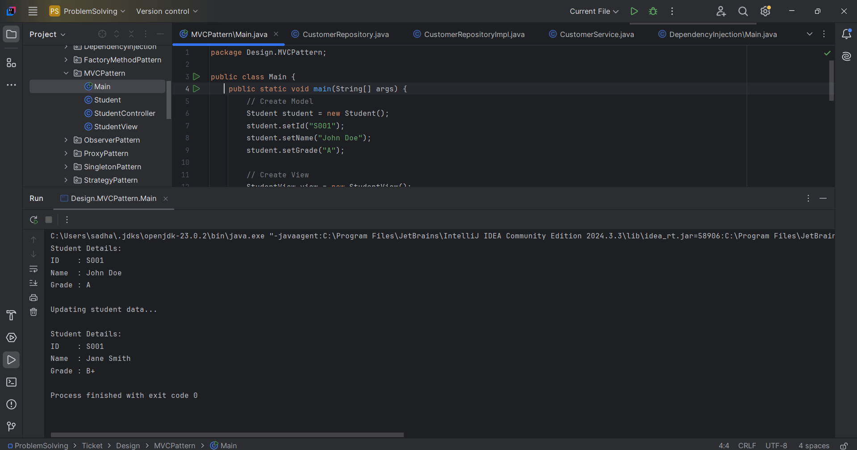

**Exercise 11: Implementing Dependency Injection**

**Main.java:**

package Design.DependencyInjection;

public class Main {

    public static void main(String[] args) {

        CustomerRepository repository = new CustomerRepositoryImpl();

        CustomerService service = new CustomerService(repository);

        service.getCustomerDetails("CUST001");

    }

}

**CustomerService.java**

package Design.DependencyInjection;

public class CustomerService {

    private CustomerRepository customerRepository;

    public CustomerService(CustomerRepository customerRepository) {

        this.customerRepository = customerRepository;

    }

    public void getCustomerDetails(String id) {

        String customer = customerRepository.findCustomerById(id);

        System.out.println("Customer found: " + customer);

    }

}

**CustomerRepositoryImpl.java:**

package Design.DependencyInjection;

public class CustomerRepositoryImpl implements CustomerRepository {

    @Override

    public String findCustomerById(String id) {

        return "Customer{id='" + id + "', name='Alice Johnson'}";

    }

}

**CustomerRepository.java:**

package Design.DependencyInjection;

public interface CustomerRepository {

    String findCustomerById(String id);

}

**Output:**

